Bailey, Taylor 3/14/2018 18SP_F2 IST190 LINUX Essentials (W02)

Lab1

Lab1-1.4-5a

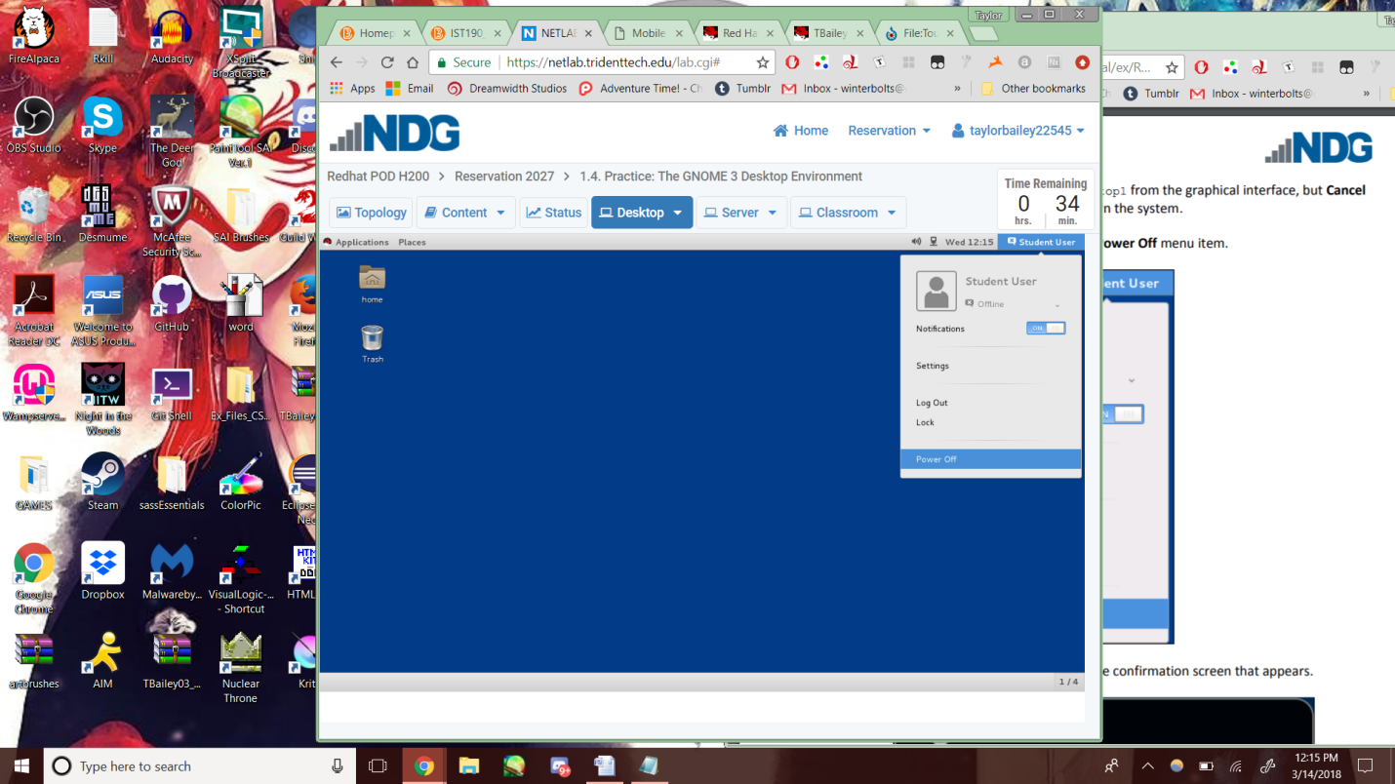

Lab1-1.7-12

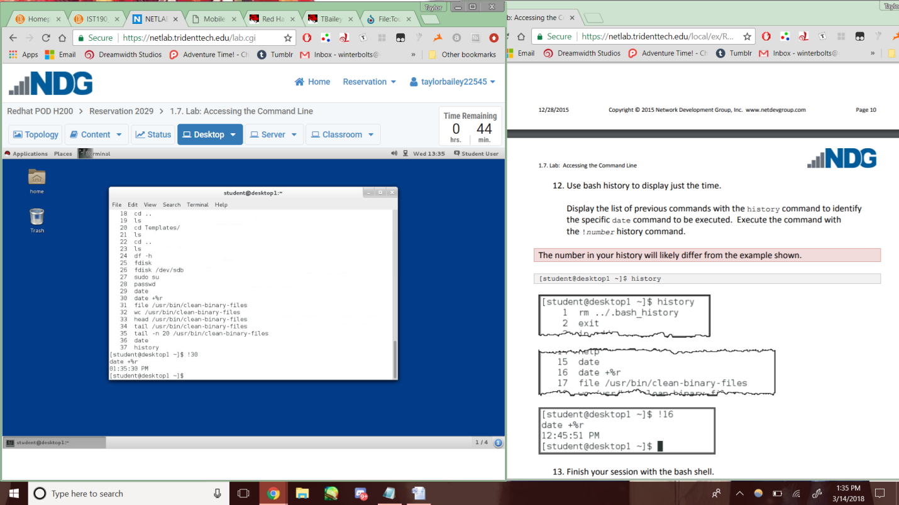

Lab1-2.6-11

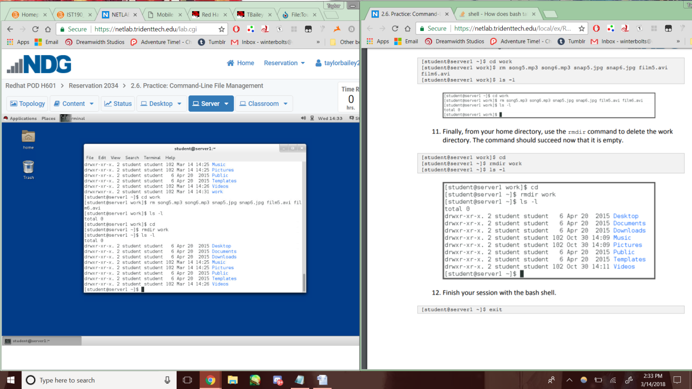

Lab1-2.9-17

